Project Development Phase
Model Performance Test

Date | 18 February 2025
Team ID | LTVIP2026TMIDS87366
Project Name | Prosperity Prognosticator: Machine Learning for Startup Success Prediction
Maximum Marks | 10 Marks

Model Performance Testing:
Project team shall fill the following information in model performance testing template.
S.No. | Parameter | Values | Screenshot
 | Metrics | Classification Model:  Accuracy Score:  Training Accuracy = 1.00  Testing Accuracy = 0.81  Classification Metrics:  For Class 0 (Closed Startups):  Precision = 0.78  Recall = 0.62  F1-score = 0.69  For Class 1 (Acquired Startups):  Precision = 0.81  Recall = 0.91  F1-score = 0.86  Overall Performance:  Weighted F1-score = 0.80 | 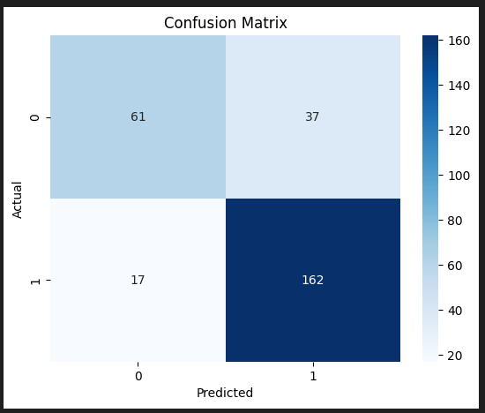  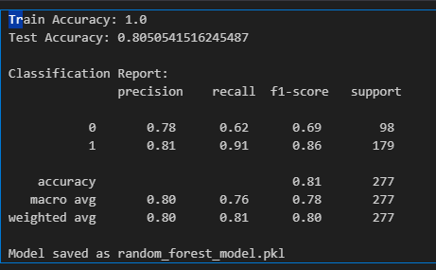
 | Tune the Model | Hyperparameter Tuning – The Random Forest model was trained using default parameters. Model performance can be improved further by tuning parameters such as number of estimators, tree depth, and feature selection.  Validation Method – The dataset was split into training and testing sets using the train-test split method. 70% of the data was used for training and 30% for testing to evaluate the model performance on unseen data.  Model Saving – After training and evaluation, the model was saved as random_forest_model.pkl so that it can be reused in the Flask web application without retraining. | 

